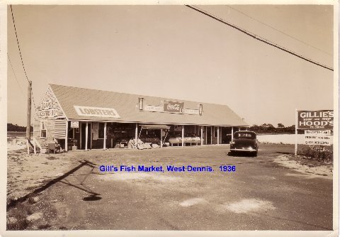

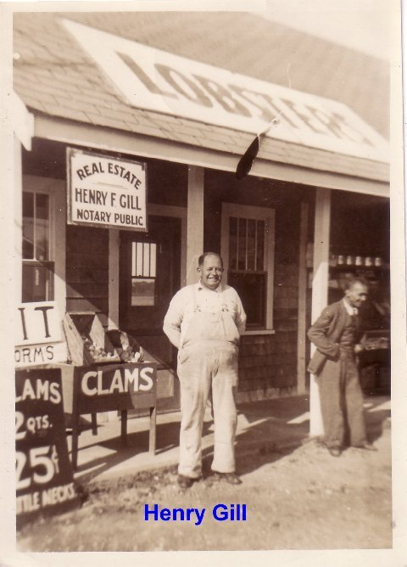

In a message dated 1/27/2008 9:04:34 P.M. Eastern Standard Time, jbarkerblitz@hotmail.com writes:
Great shots - obviously what came to be Dockside and the Bait shop.
Jim, that's dated 1953 but, frankly, I don't recognize it. This may have become Dockside and the Bait Shop. What do you think?

