After you get you body shaped you now have to decide how you want to finish it. I use two methods. I will paint or I will put a foil base and apply paint over it. I guess I will do the foil first! In my opinion vc is the best at it!
I am sure he will add much more to this. He has many tricks
As always PLEASE take the precautions to ensure your safety while working with power tools. If you are not of age PLEASE ask for assistance from an adult.
Before I start I like to have the lip in if I am doing a crank-bait. I also like to have the screw eyes inserted. Your blank will be sanded smooth to ensure a good platform to start your work.
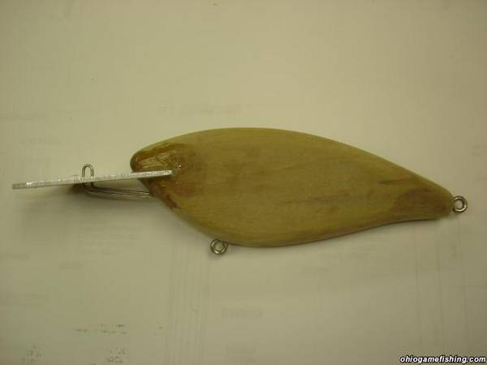
To get a scale effect there are many ways to achieve it. One method is to apply a mesh down first as a base. The second is to apply the foil and imprint with an object to press in the pattern into the foil and wood at the same time. I will show the mesh method.
Mesh, it can be bought at a fabric store or it can even be egg sack type bagging material. Patterns are unlimited, the sky is the limit.
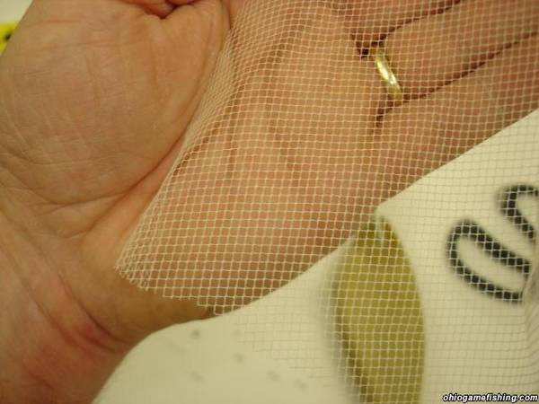
You need to get the mesh to stick to the lure body. There are many glues to do this. Rubber cements and contact type adhesives. Apply a thin layer of glue and let it set per instructions. Apply the mesh and wrap around the body. You can trim the mesh with a razor blade. Continue to do the other side also. You can overlap the mesh and cut both at the same time to get a clean cut.
The foil, I like to use HVAC metal duct tape.
The metal tape comes in different widths. On bigger bait you will not be able to cover the entire lure. Bass baits you can. Let the foil overlap and trim both at the same time. It will give you a nice seam.
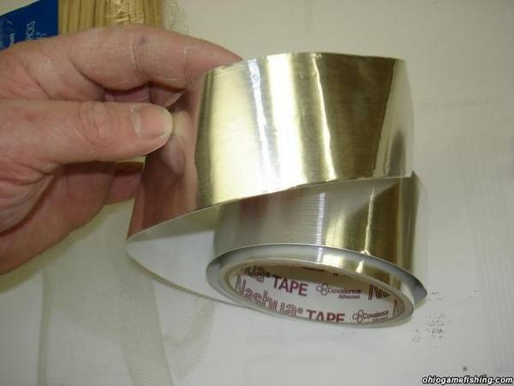
It has a peel and stick backer that adheres well to the mesh and wood. Cut your piece to length and start to peel the tape. Be careful not to have it stick to itself. Keep it stretched out the best you can. It will crinkle but don't worry.
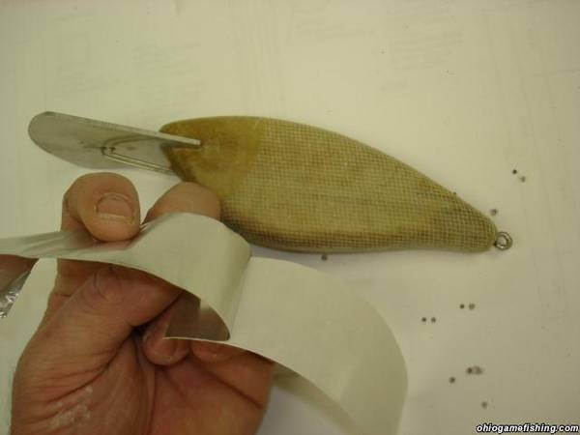

I like to start down the lateral line and work out. (center to sides) Take your thumb or the a blunt object and press the pattern in. The foil is delicate be a bit careful. The thumb works well for me. Try to get all the surface down if you can.
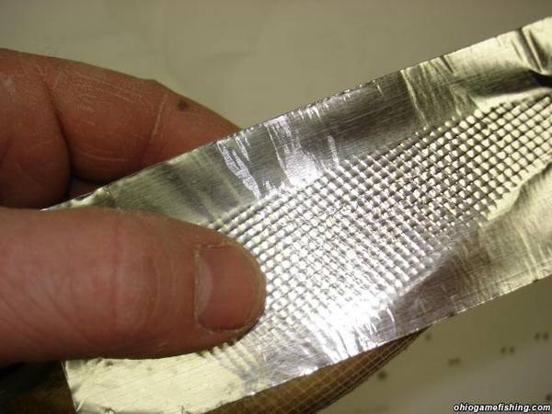
The metal tape comes in different widths. On bigger bait you will not be able to cover all of the lure. Bass baits you can. Let the foil overlap and trim both at the same time. It will give you a nice seem.
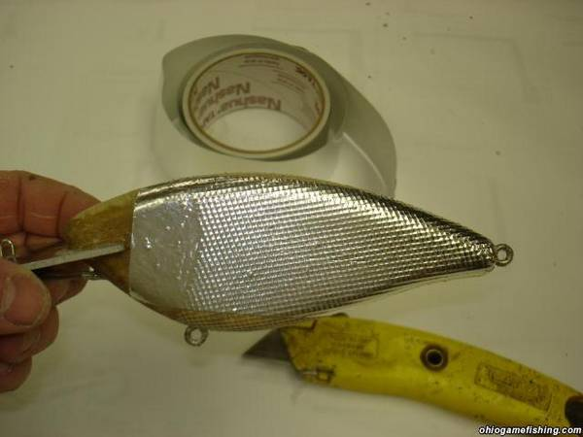

The non-covered areas, Don't worry about this. You will cover the bait in epoxy. Epoxy is a great thing to level the playing field. After you coat the lures it will be level smooth to start you paint steps. Here is a copper foil that I applied the epoxy on. It is back to smooth. Over the next couple of nights I will add the other steps to finish this lure. We will do it together on here. You can see that I purposely made imperfections under my foil. There are glue bumps and other imperfections. You watch how those will fade as we go down the road of finish steps. It can be any level that you want to take it to. It is all good in my book!
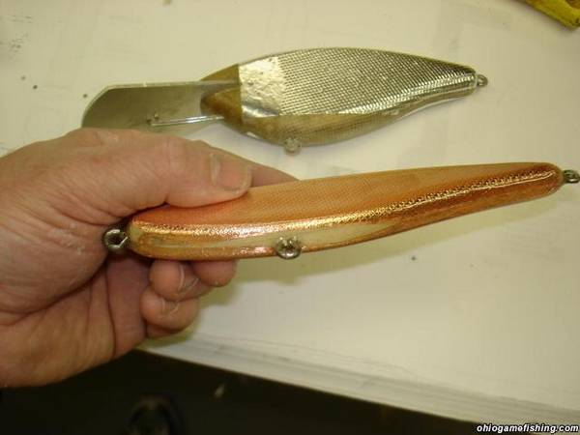
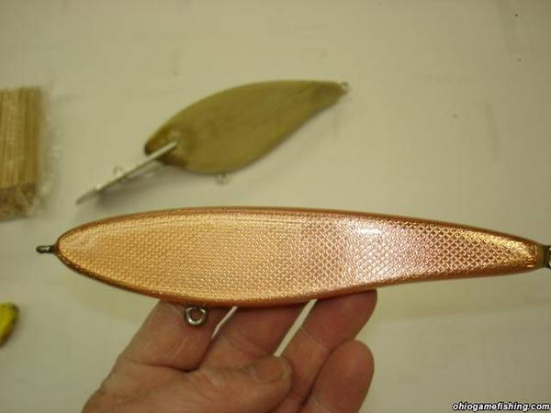
Vc will show you some neat tricks also with the gills and other methods. He is very good at it.

You are almost ready for paint. I like to clean out the holes as I go. It will let the paint around the screw eyes be buried and also reduce the chipping at the end. I take a small drill bit to do this.
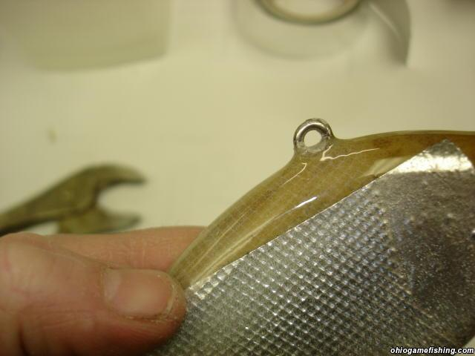
Next I will tape off the lip if there is one. Then I will hold the bait by the back srew eye with a pair of channel locks. It makes it easy to hold while painting.
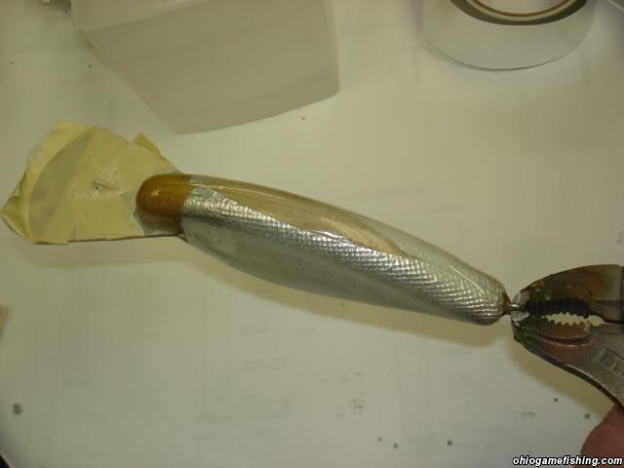
The bait is ready for paint now. Before the paint the bait does not look pretty at all. This is when the transformation is about to start.
For this bait let’s do a shad. It is a very common forage fish and should work well.
You might be limited in how you may apply your paint. There all different levels of airbrushes. I have a very basic one. I think it is an entry level one that I bought second hand. I got it for 50 dollars. I had some extra stuff that I haven't used yet. You can use compressed air cans with mini paint guns that can be purchased at Walmart and craft stores. You might also use spray cans but the control is very limited and would not suggest this, but it can be done.
I like to paint the belly first. Most shad have a white belly so we will use "white" I will start down the center and work to the edges while turning the bait. This is where you will fade the sides in. You can choose how much foil that you want to cover or not cover.
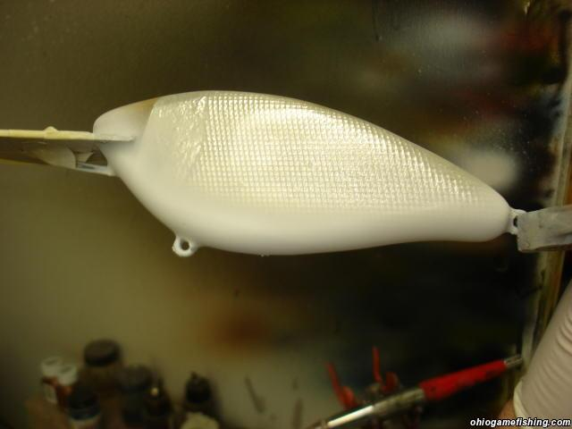
You can see that the uncovered foil areas will start to vanish.
Next I like to add a highlight color. I will use purple for this one. It can any color you choose.
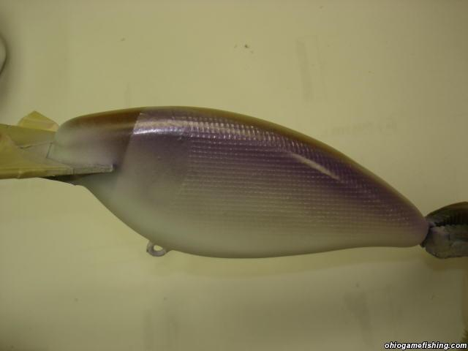

Next I will do the back. Black is my color of choice. I will go down the back and fade the sides. I will take it around the head next.
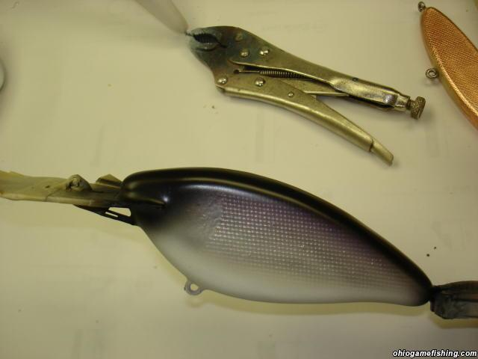

I will let the bait dry overnight. Now it is ready for the second epoxy coat.
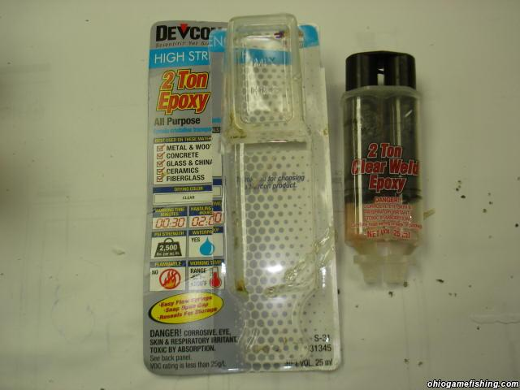
The amount of epoxy will vary on the size of your bait. On this bait it will need about 1/2 the amount provided in the package. I like to mix it in a plastic Dixie cup with a wood stir stick. I found the ones with the wax coating will cause problems with the wax scraping off during the mixing of the two parts. You can use throw away brushes or use an artist brush with a very good cleaning of that brush with-in minutes after the coat. Once the epoxy starts to harden you can ruin an 8 dollar brush in a hurry!
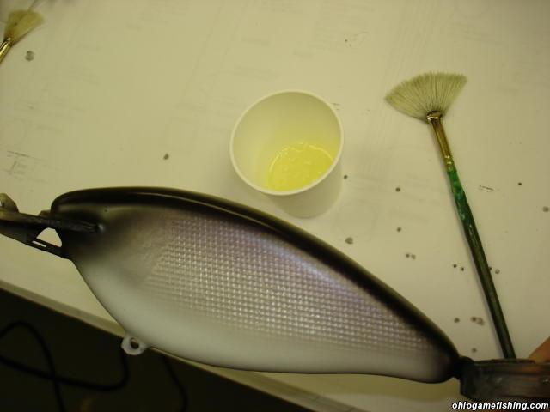
Mix your epoxy with a stir stick and apply to your bait.
I like to hold the bait and then transfer it to the wheel. The crank baits are easy to move to the wheel. They have a lip to hold on to! LOL After you have the bait attached start the wheel or let hang to dry.
On the wheel you will have small bubbles to deal with. As it is spinning on the wheel I will take a heat gun or blow dryer to lightly go over the bait to release the bubbles. Do not heat too much of your epoxy will start to gather in tumbling-spinning masses of uneven coatings. You can take the brush and lightly swipe the run while spinning. Also if you heat it too much the coating will get to thin for coverage of the bait. It is like Honey and water. It is a fine line that you will start to recognize after a couple of baits.
Here is the complete 2nd step. It is starting to look like a finished bait.
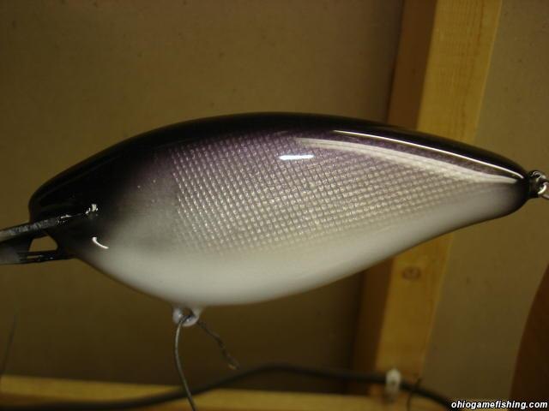
After this dries we will paint the head and fins to take it down the home stretch!

Well it is time for the final step.
After the epoxy dries, next day, we are ready to paint the head and fins. The way I do this is to take thin plastic, like off an empty milk jug, or to buy stencil plastic at the hobby store. You can cut any shapes you like. There are plenty of fish ID photo's on the web that you can track down to get good close-ups of the bait fish and their characteristics.
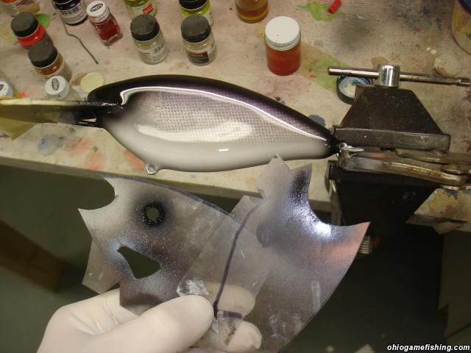
I like to paint the gill plate with black and paint the fin in the highlight color of the back. Place template over bait and mist color lightly.
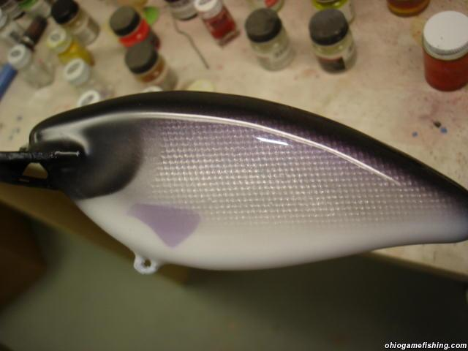

Next I will shoot a lighter color over the cheek (white or silver)and highlight the edges of the fins with black. At this time I will add the shad dot also. I took a hole punch to make the spot in the template. Works great.
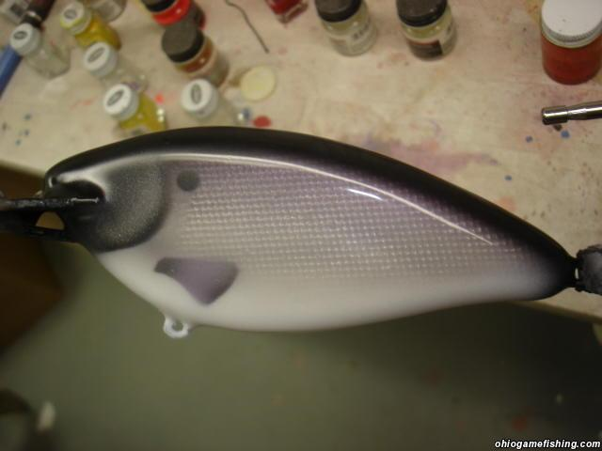
The last thing to add are the eyes. You can buy stick on eyes at many tackle stores or order from tackle supply websites. This is one that I use. It is in OHIO!!!! http://www.jannsnetcraft.com/
We are now ready for the final coat. Mix the epoxy and do as the same as step #2. It is done! Let dry and remove the next day. Clean out the screw eye holes and add the hooks.
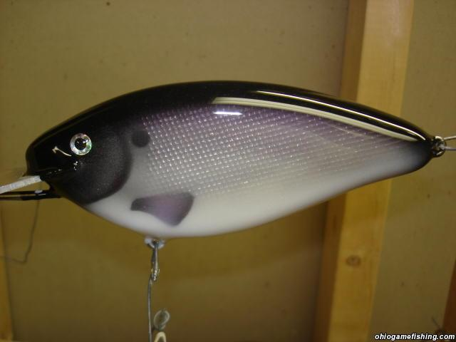
The only thing that limits you is yourself. Don't be afraid to try. I have a whole box full of rejects that I messed up along the way.
As you saw, at the start of this, my foil was not perfect! Do the best that you can. You only get better with each one. The only thing that you might have to do down the road is to recoat it in a year or two to cover up the teeth mark scratches!!!!!!!LOL

